While loop

#include<stdio.h>
int main()
{
int battery = 20;
while (battery <= 100)
{
printf("Battery is charging : %d \n", battery);
battery+=5;

}
printf("The battery is full please disconnect the charger");
}

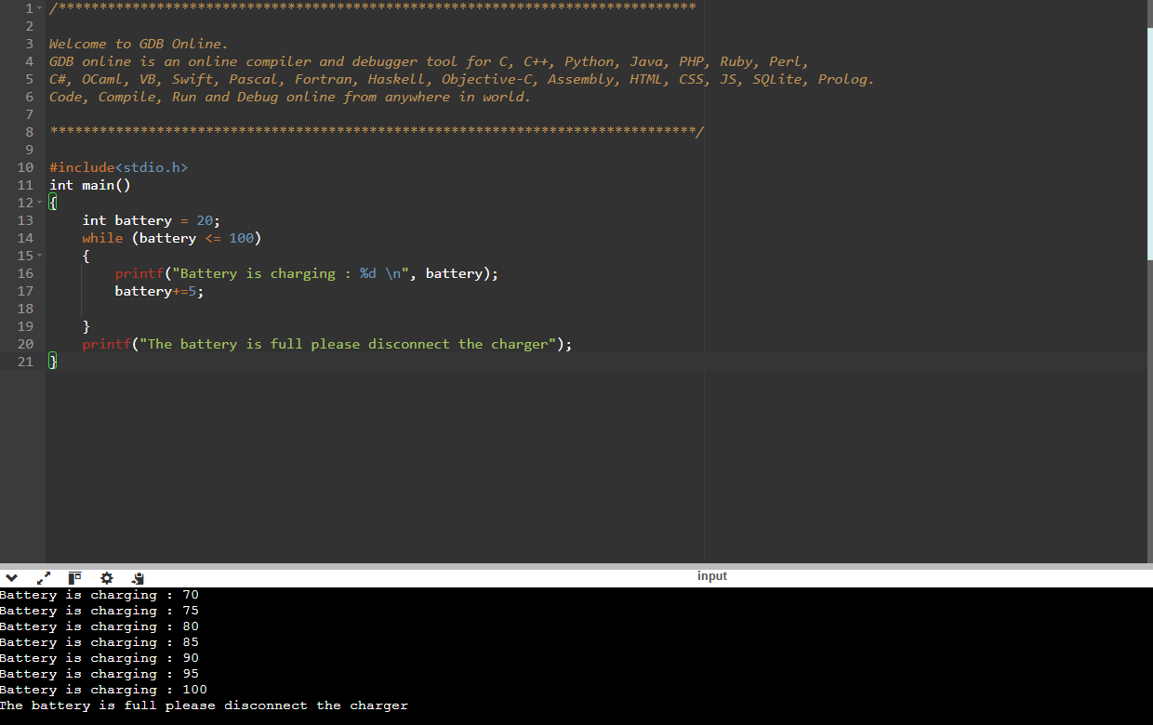

While Loop

#include <stdio.h>

int main()
{
int files_downloading=0;
while(files_downloading<=100)
{
printf("files are downloading please wait:%d \n", files_downloading);
files_downloading+=2;
}

printf("files are downloaded");
}

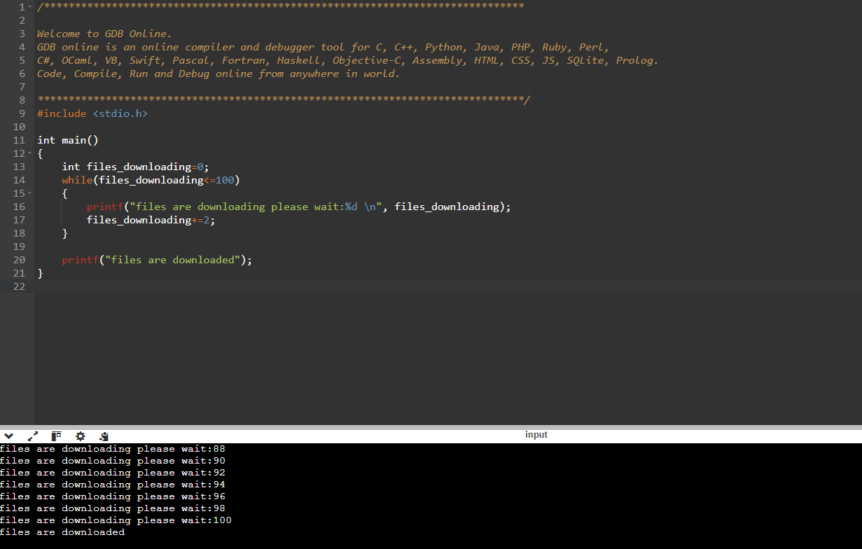

While Loop

#include<stdio.h>
int main()
{
int water_level = 0;
while (water_level<100)

{
printf("Water level = %d \n", water_level);
water_level+= 20;
}

printf("water level is full off the motor\n");
}

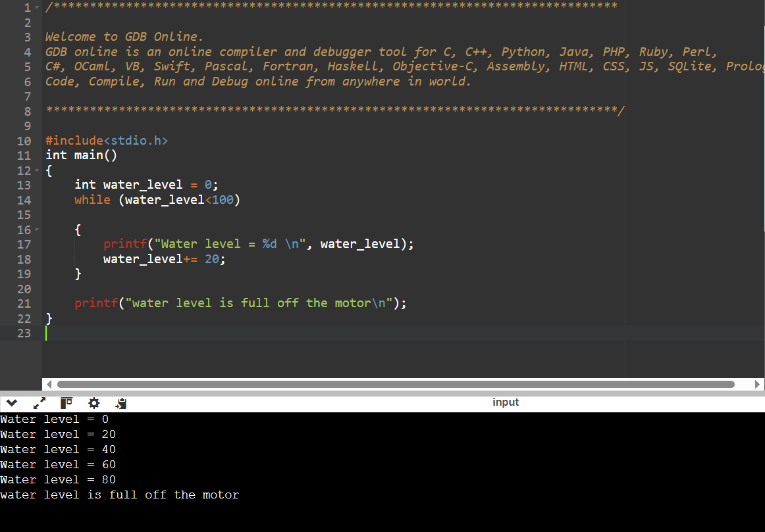
Do while

#include <stdio.h>
int main()
{
int age = 24;

do
{
printf("%d\n", age);
age+=20;
}
while(age<=100);
{
printf("the time has came my friend (RIP) ");
}
}

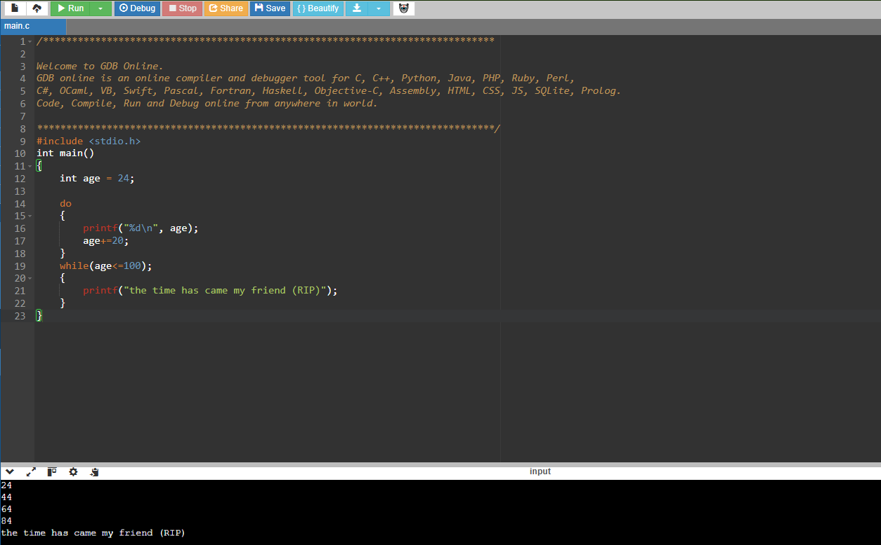

#include<stdio.h>
int main()
{
int two_table = 0;
do
{
printf("%d\n",two_table);
two_table+=2;
}
while(two_table<=20);
{
printf("two tabel upto 20");
}
}

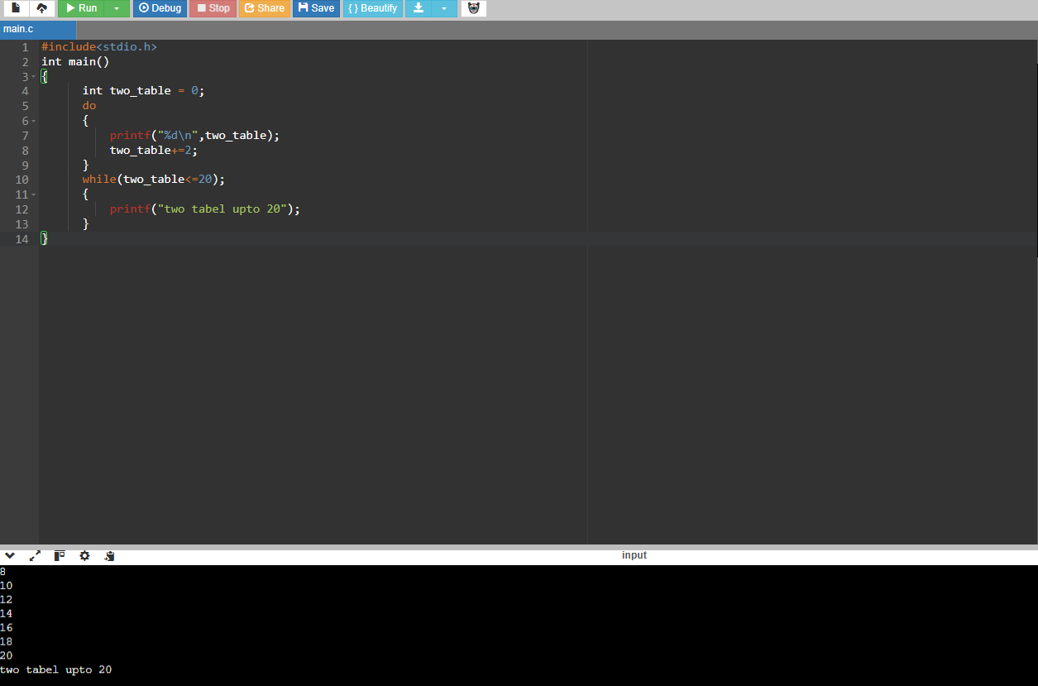

#include<stdio.h>
int main()
{
int ascending_order=100;
do
{
printf("%d\n", ascending_order);
ascending_order-=1;
}
while(ascending_order>=0);
{
printf("ascending_order from 100 to 0");
}
}

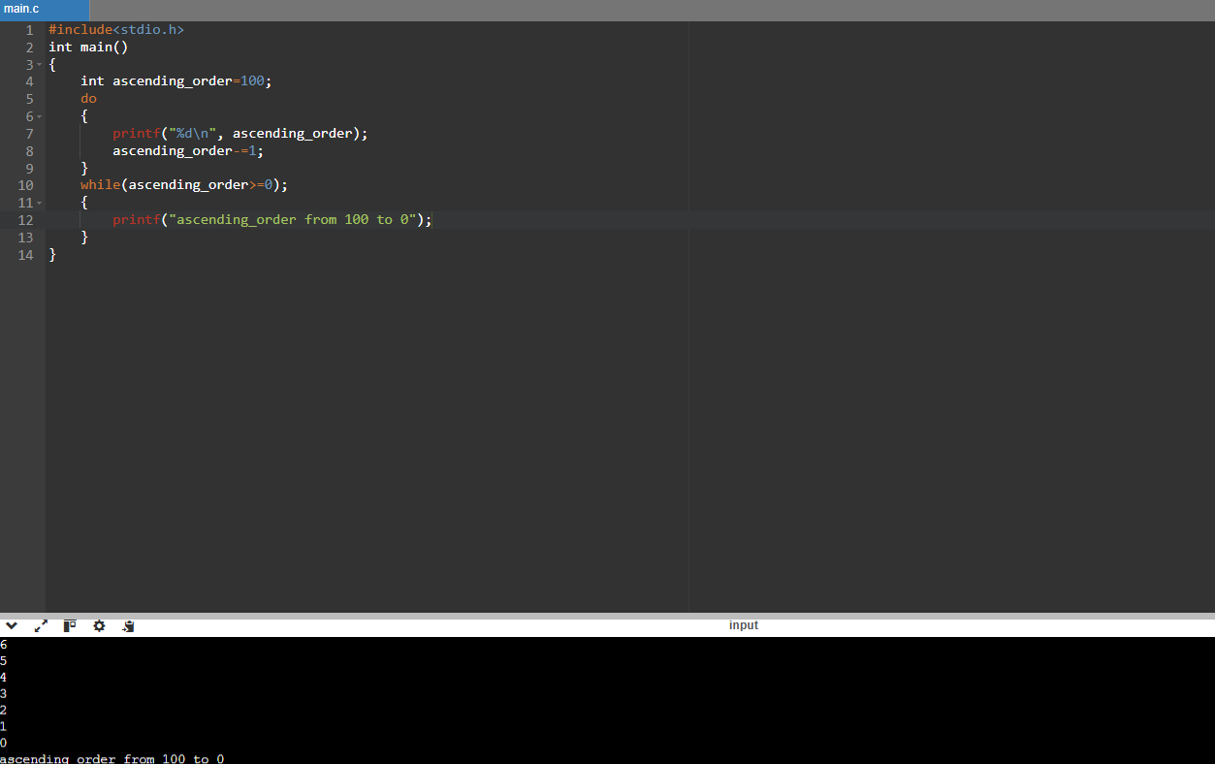

for loop

#include<stdio.h>
int main()
{
for (int class_students=1; class_students<=10; class_students++)
{
printf("%d\n",class_students);
}
return 0;

}

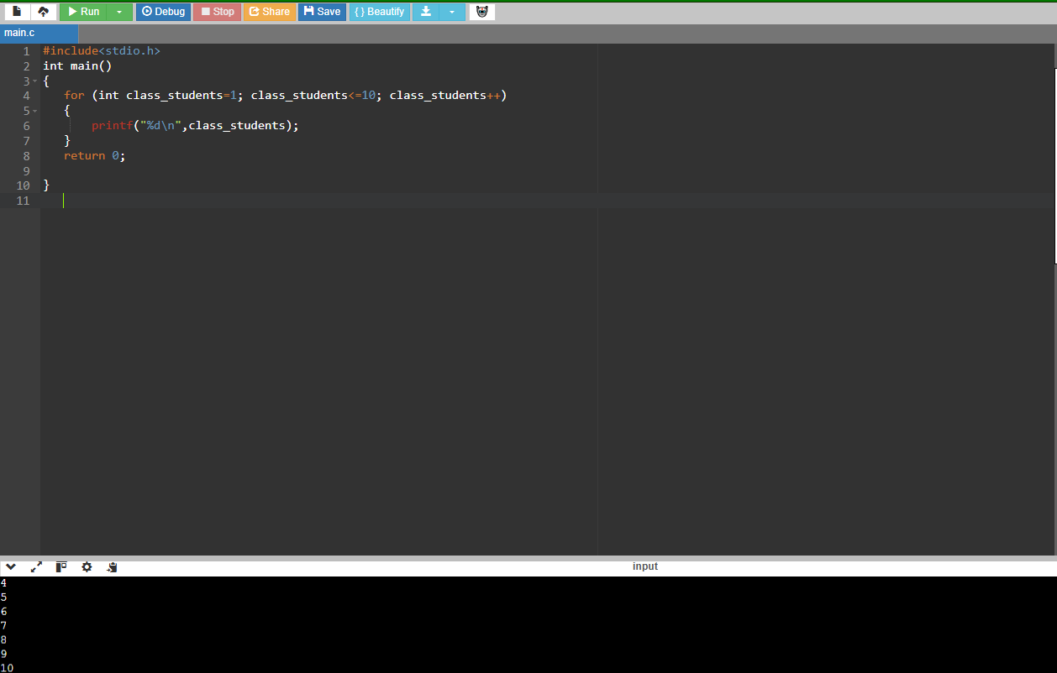

#include<stdio.h>
int main()
{
for (int classes_completed=5; classes_completed<=22; classes_completed+=1 )
{
printf("%d\n", classes_completed);
}
return 0;
}

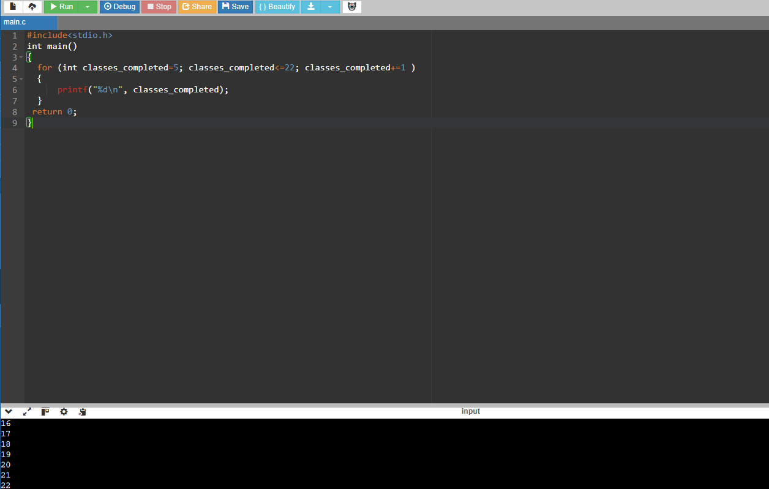

#include<stdio.h>
int main()
{
for (int i=15; i>=1;i--)
{
printf("%d\n", i);
}
}

